**Question Bank**

**A.1**

If-else Statements

**A.2**

Switch Statement

**A.3**

do-while, bottom

**A.4**

for( ; ;){

//Execution Code

}

**A.5**

While(true){

//Execution Code

}

**A.6**

do-while loop

**A.7**

The continue keyword is used to end the current iteration in a for loop (or a while loop) and continues to the next iteration.

**A.8**

1 bit

**A.9**

for loop

**Flipped Practical’s**

**A.1**

1. Output:

second string

third string

1. Graphical user interface, text, application

   Description automatically generatedIn the above program, the value of aNumber =3. So, the else statement is executed which prints the string ‘second string’. And there is also a print statement outside the for loop which prints the string ‘third string’.
2. Program using only spaces and line breaks.Graphical user interface, text, application

   Description automatically generated
3. Program using { and }

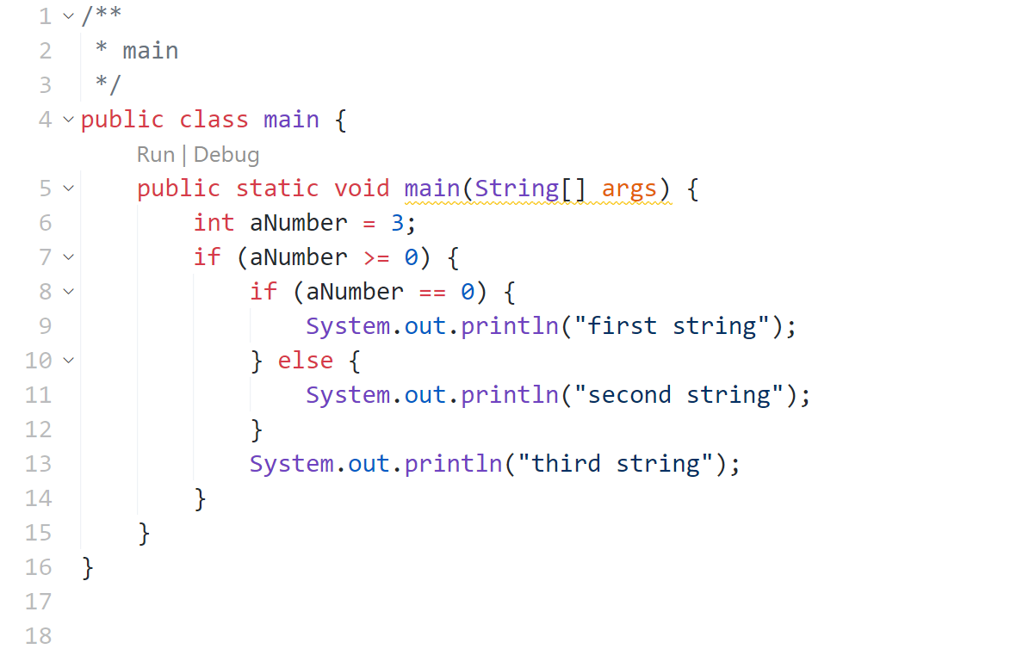

**A.2**

Commas are written instead of semicolon.

Correct: for(int k=2; k<=2; k++);

**A.3**

Curly Braces

**A.4**

6